Table of Contents

1. Running the CSV/Excel Data collation program 2

Outcome of Collation 7

1. No error 7

2. Errors found 8

# Running the CSV/Excel Data collation program

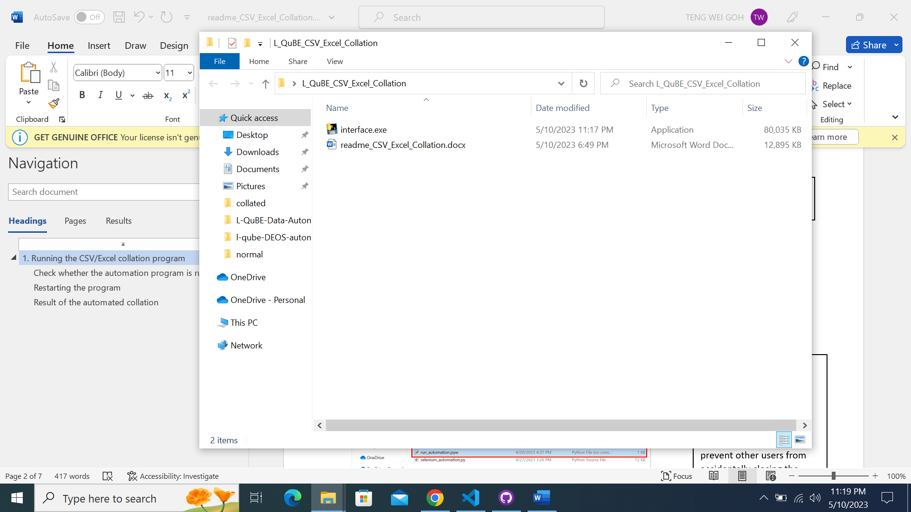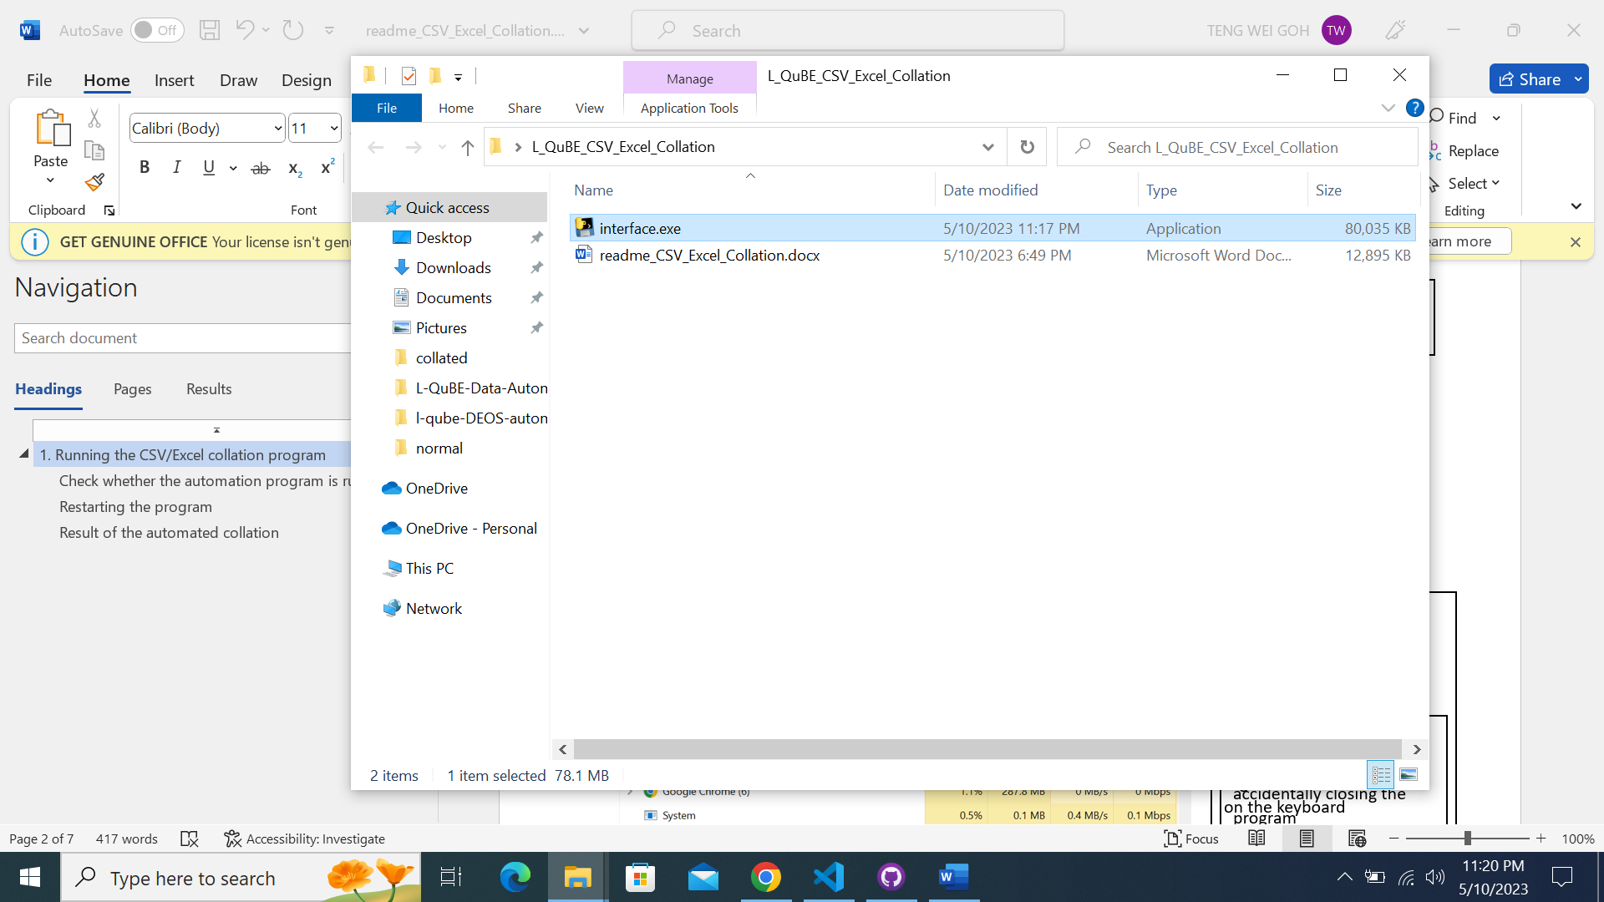

Double-click the ‘interface.exe’ file and the program will run.

Please wait for approximately 13 seconds for the program to start up.

Navigate to the folder where the files are located

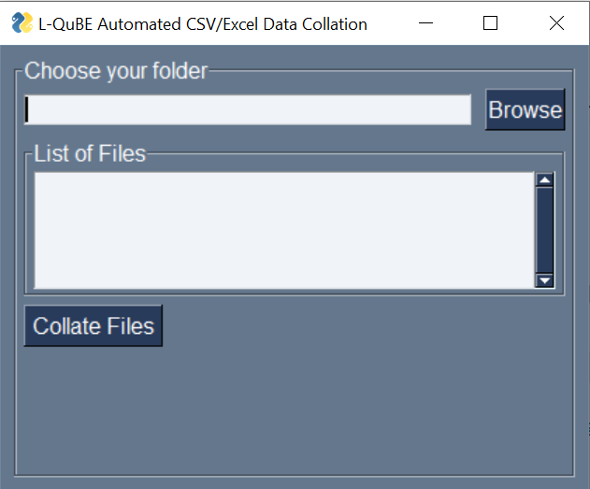

The following Graphical User Interface will be shown.



Click on the ‘Browse’ button to choose the folder where the CSV/Excel files to be collated are located.

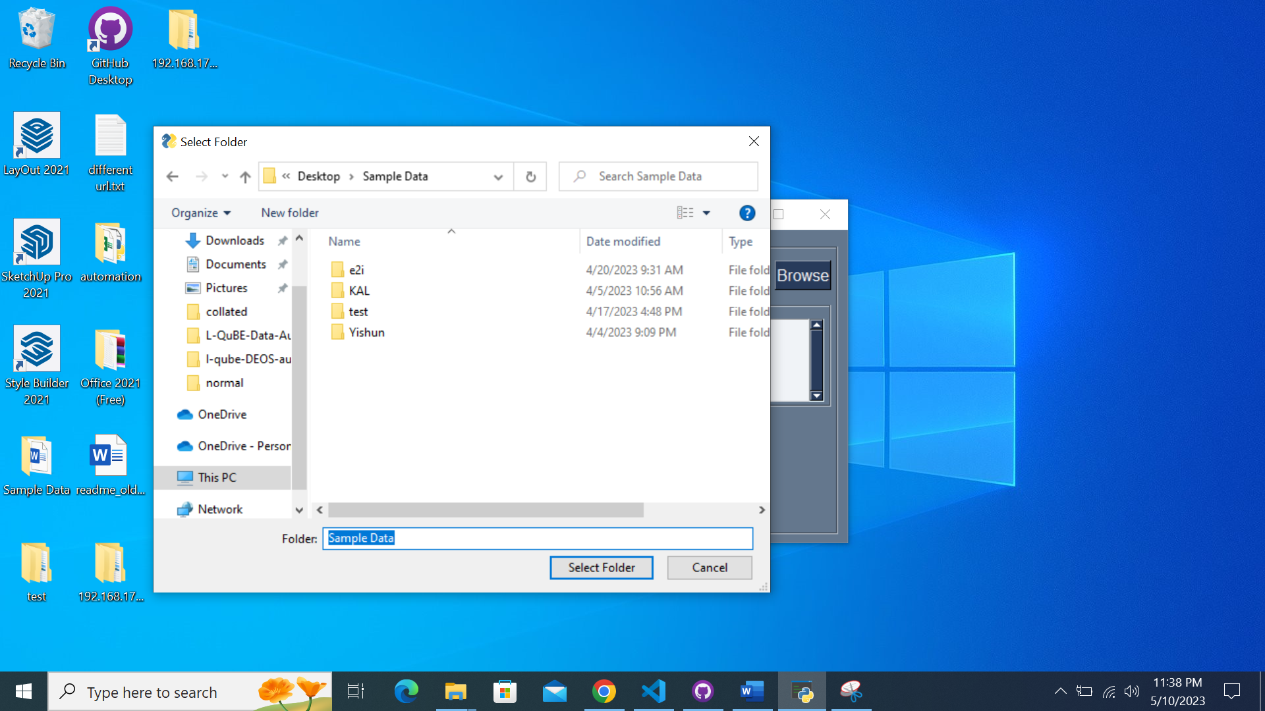

The in-built File Explorer will pop up once the ‘Browse’ button is clicked.

Once you navigate to your desired folder, please click ‘Select Folder’ button.

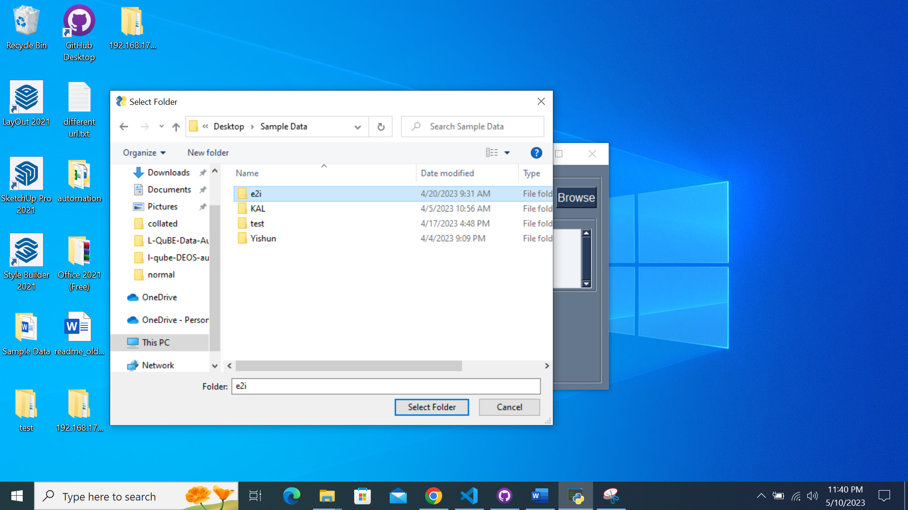

Once you select your desired folder by clicking the folder, please click ‘Select Folder’ button.

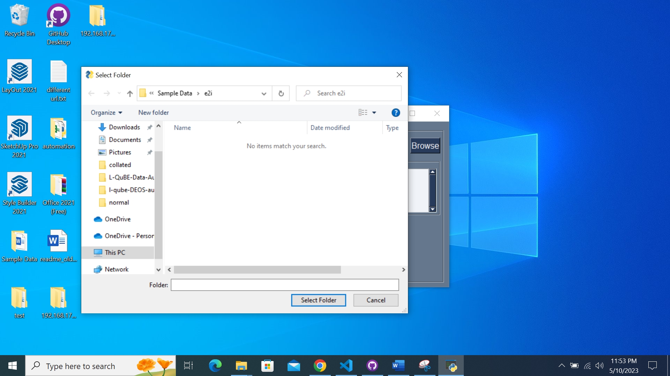

Please take note that you **will not be able to see the files located** inside the folder if you click into the folder.

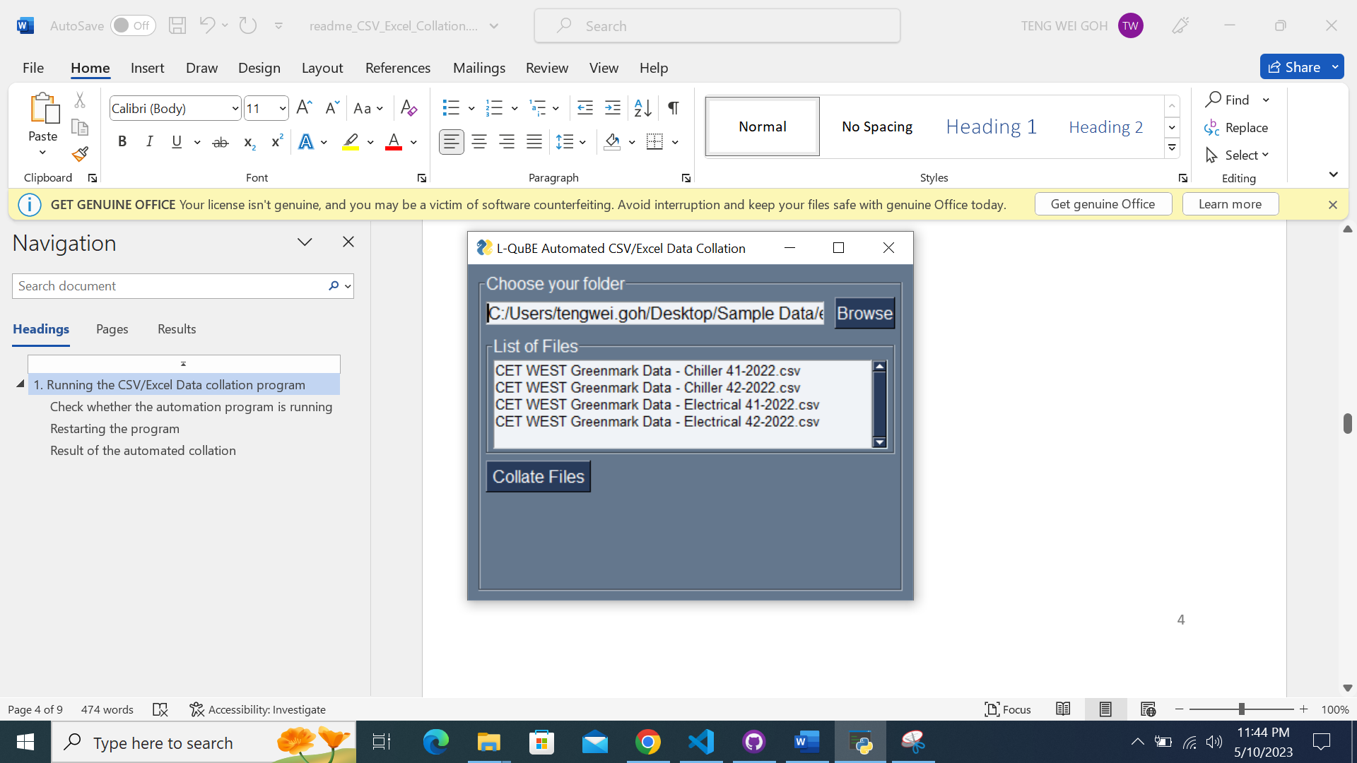

Ensure that the file names **do not end with ‘collated.csv’ or ‘collated.xlsx’** as the program will ignore such files.

After clicking on the ‘Select Folder’ button, the list of files inside the folder will be displayed in this text box.

Check that every file that you wish to collate are inside the folder.



After checking that the files are correct, you may click on the ‘Collate Files’ button for the collation process to begin.

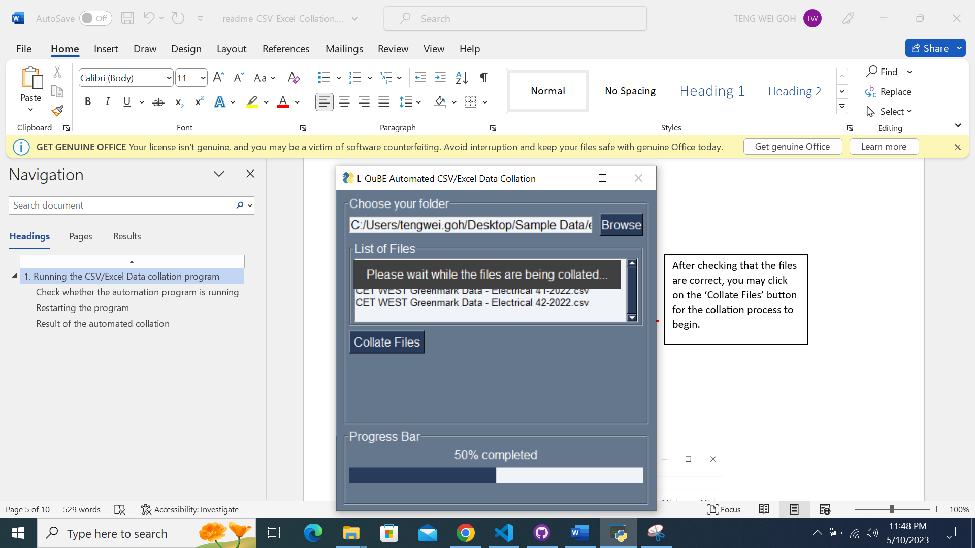

There will be a

1. Pop-up to notify you that the collation process has begun.

2. Progress bar at the bottom to notify you about the progress of the collation.

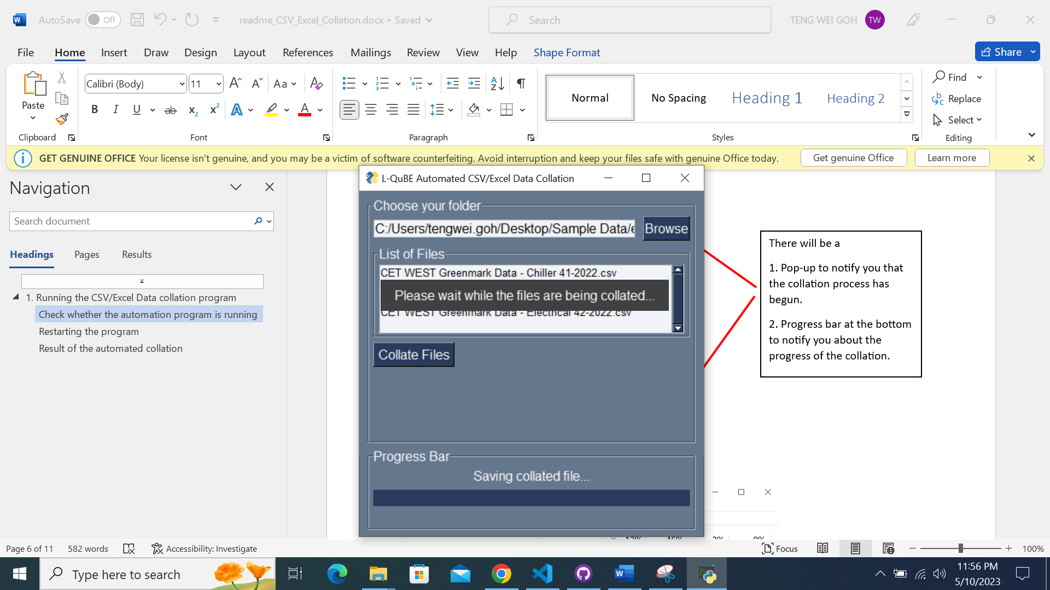

When the message ‘Saving collated file…’ appears, it means the collation is near completion.

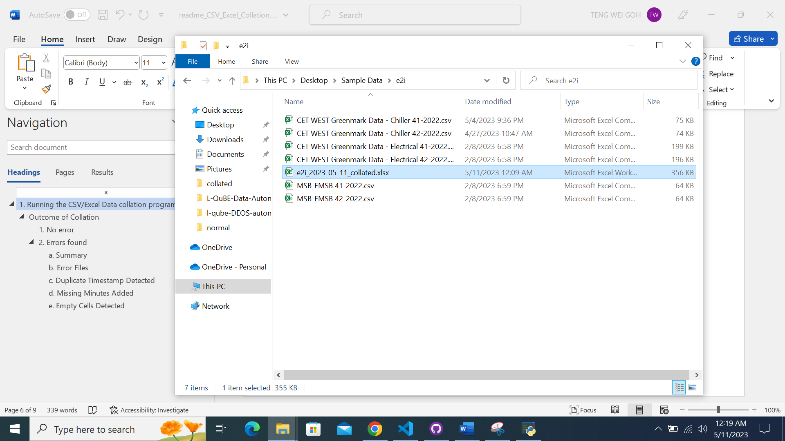

The output collated excel file will be in the **same folder** which was chosen for collation.

The name of the collated file will be **{name_of_folder}_{today’s_date}_collated.xlsx**

## Outcome of Collation

### No error

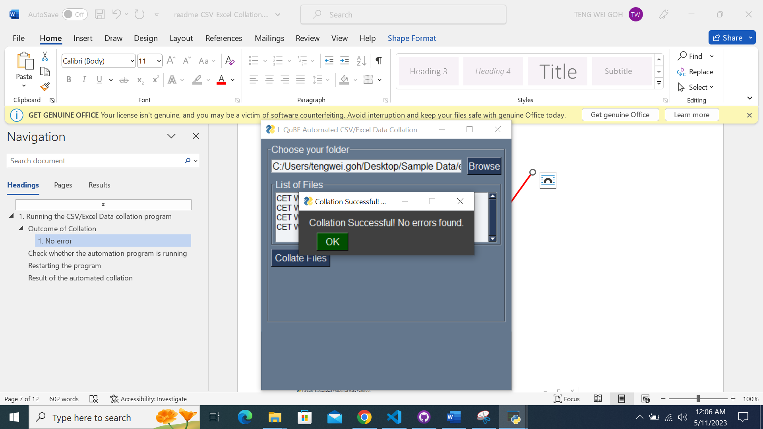

When there are no errors/faults found, this pop-up box will appear indicating no error/faults has been found and no further action needs to be taken.

### Errors found

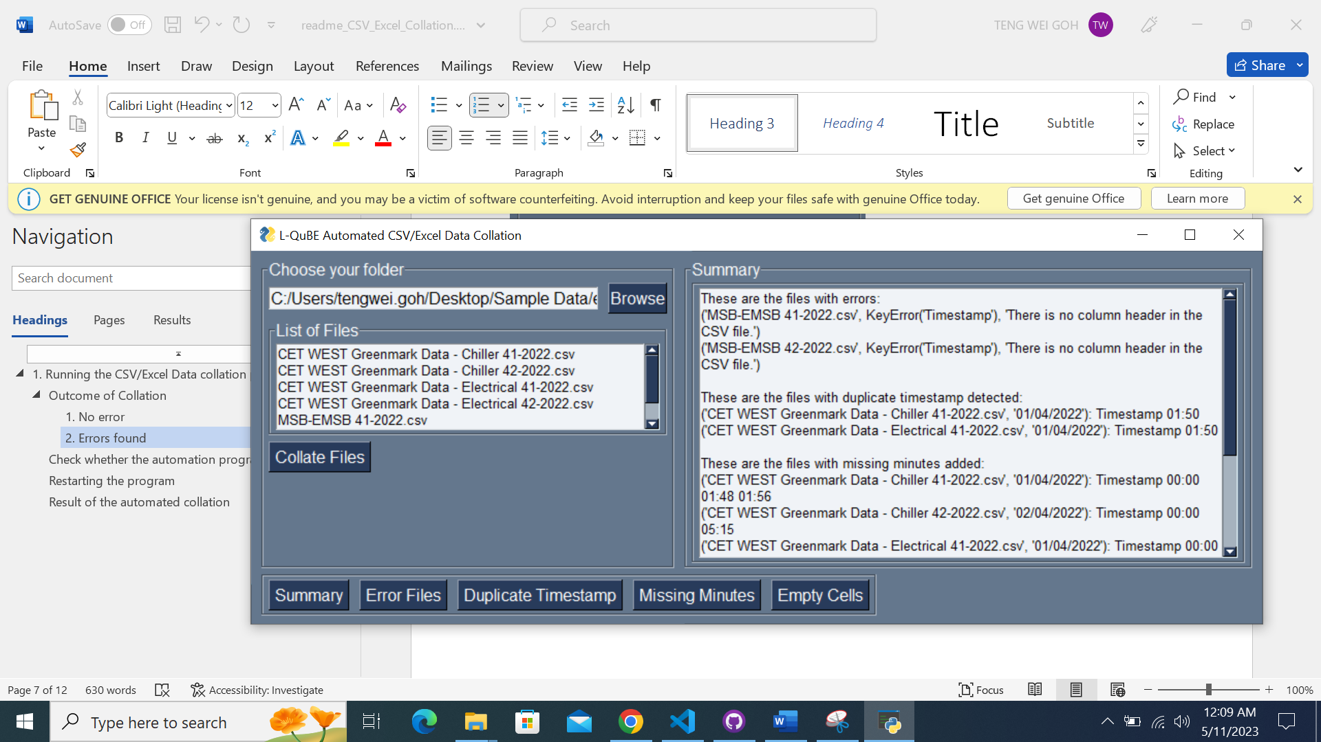

When there are any errors/faults found, this GUI will be displayed to notify you of the errors/faults found.



The buttons below will be used to navigate to the respective error page, which will be further explained below.

#### Summary



The summary of the errors/faults will be displayed in the Summary page.

Click the ‘Summary’ button to navigate to the Summary page.

#### Error Files

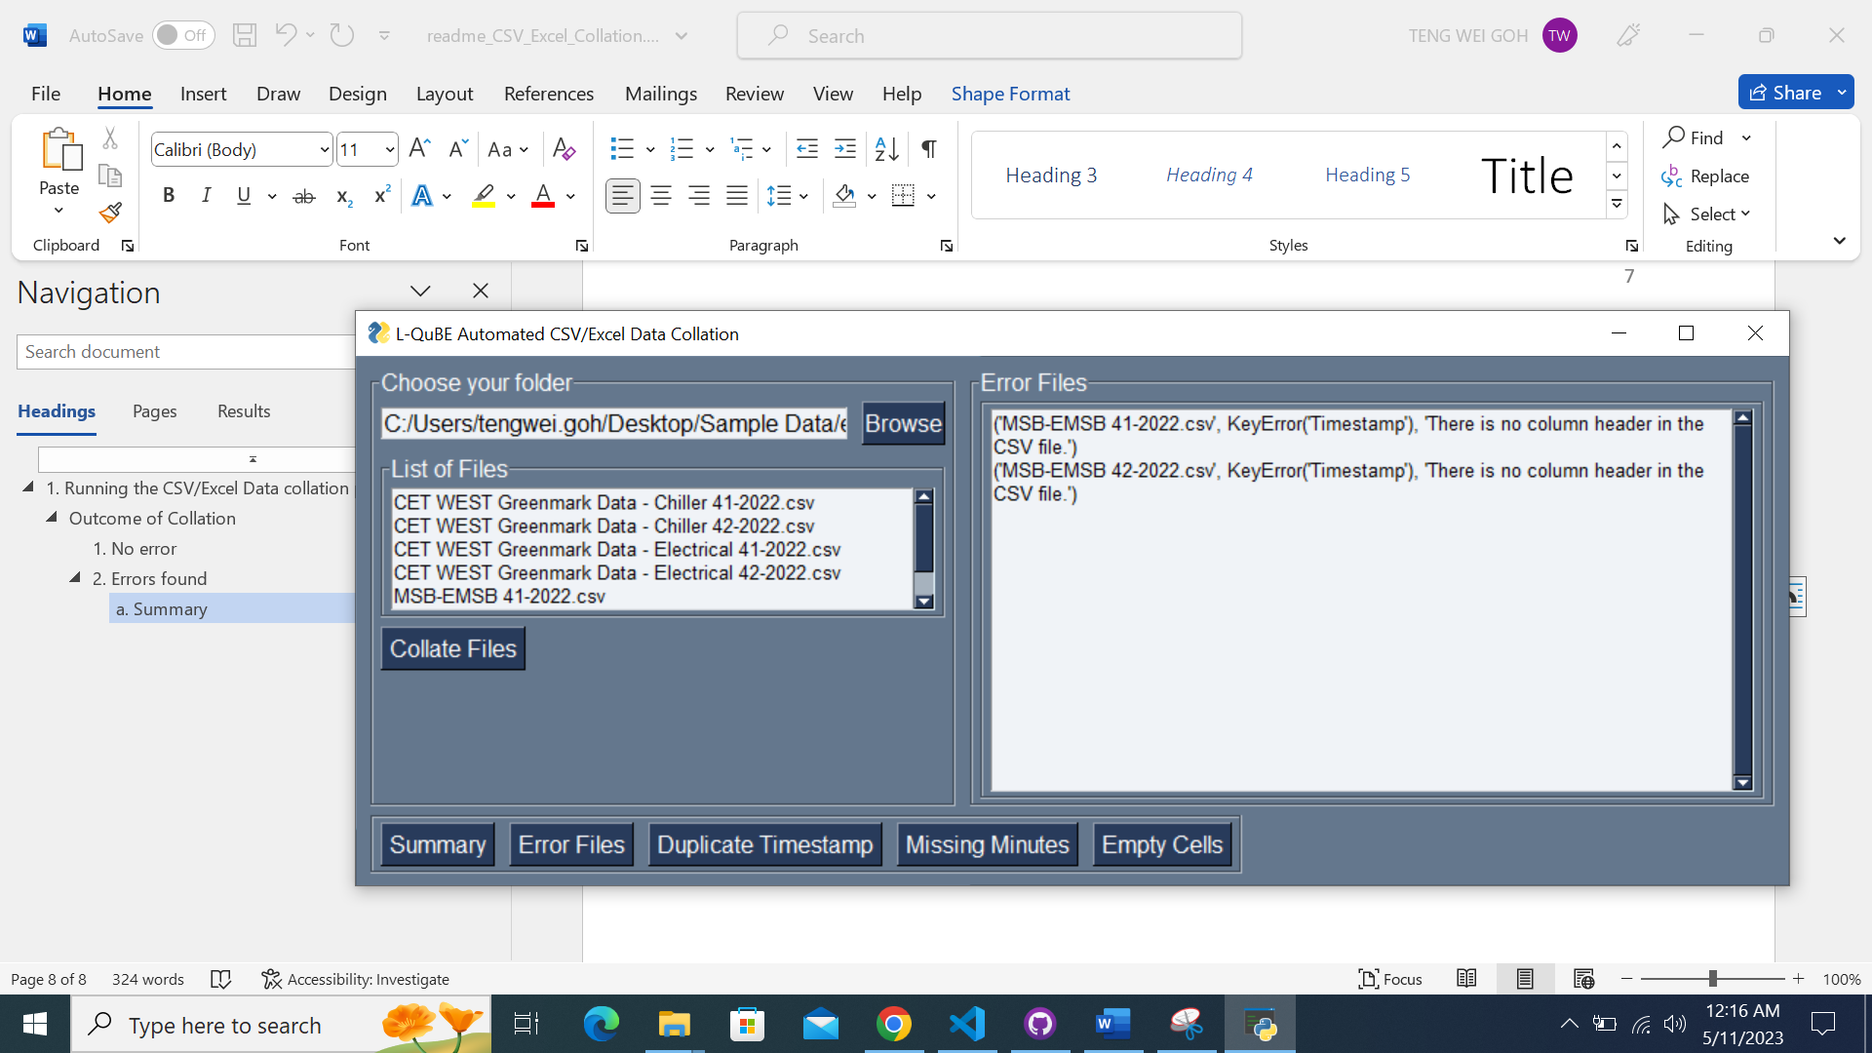

Click the ‘Error Files’ button to navigate to the Error Files page.

Any error file(s) detected will be displayed in the Error Files page.

Error files are files in which the data of these files will not be included in the collated file.



The error file(s) will be displayed along with the error of the file.

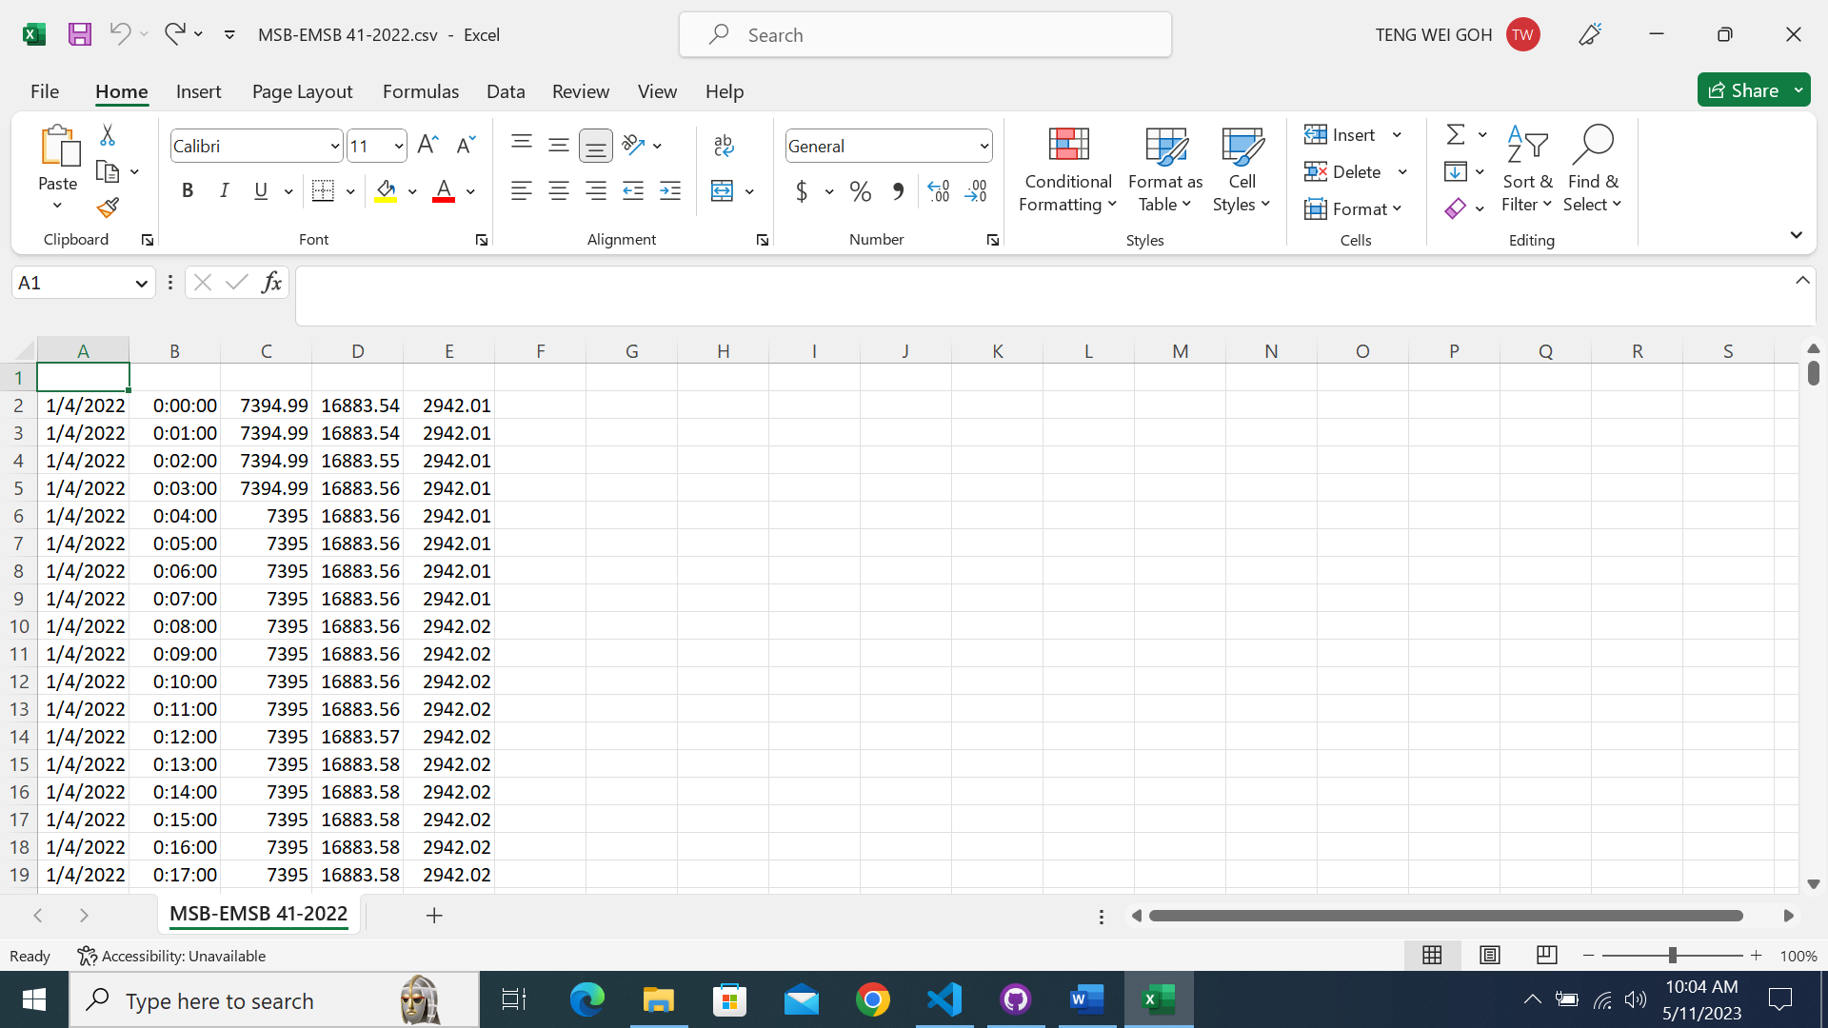

As indicated by the program, the file ‘MSB-EMSB 41-2022.csv’ is not collated due to missing column header, which can be verified by the evidence on the left.

Likewise, it is the same for the file ‘MSB-EMSB 42-2022.csv’.

This is the most common error that will appear.

#### Duplicate Timestamps Detected

Any duplicate timestamp(s) detected will be displayed in the Duplicate Timestamp page.

Duplicate timestamps occurs when a data is recorded twice or more for the same timestamp.

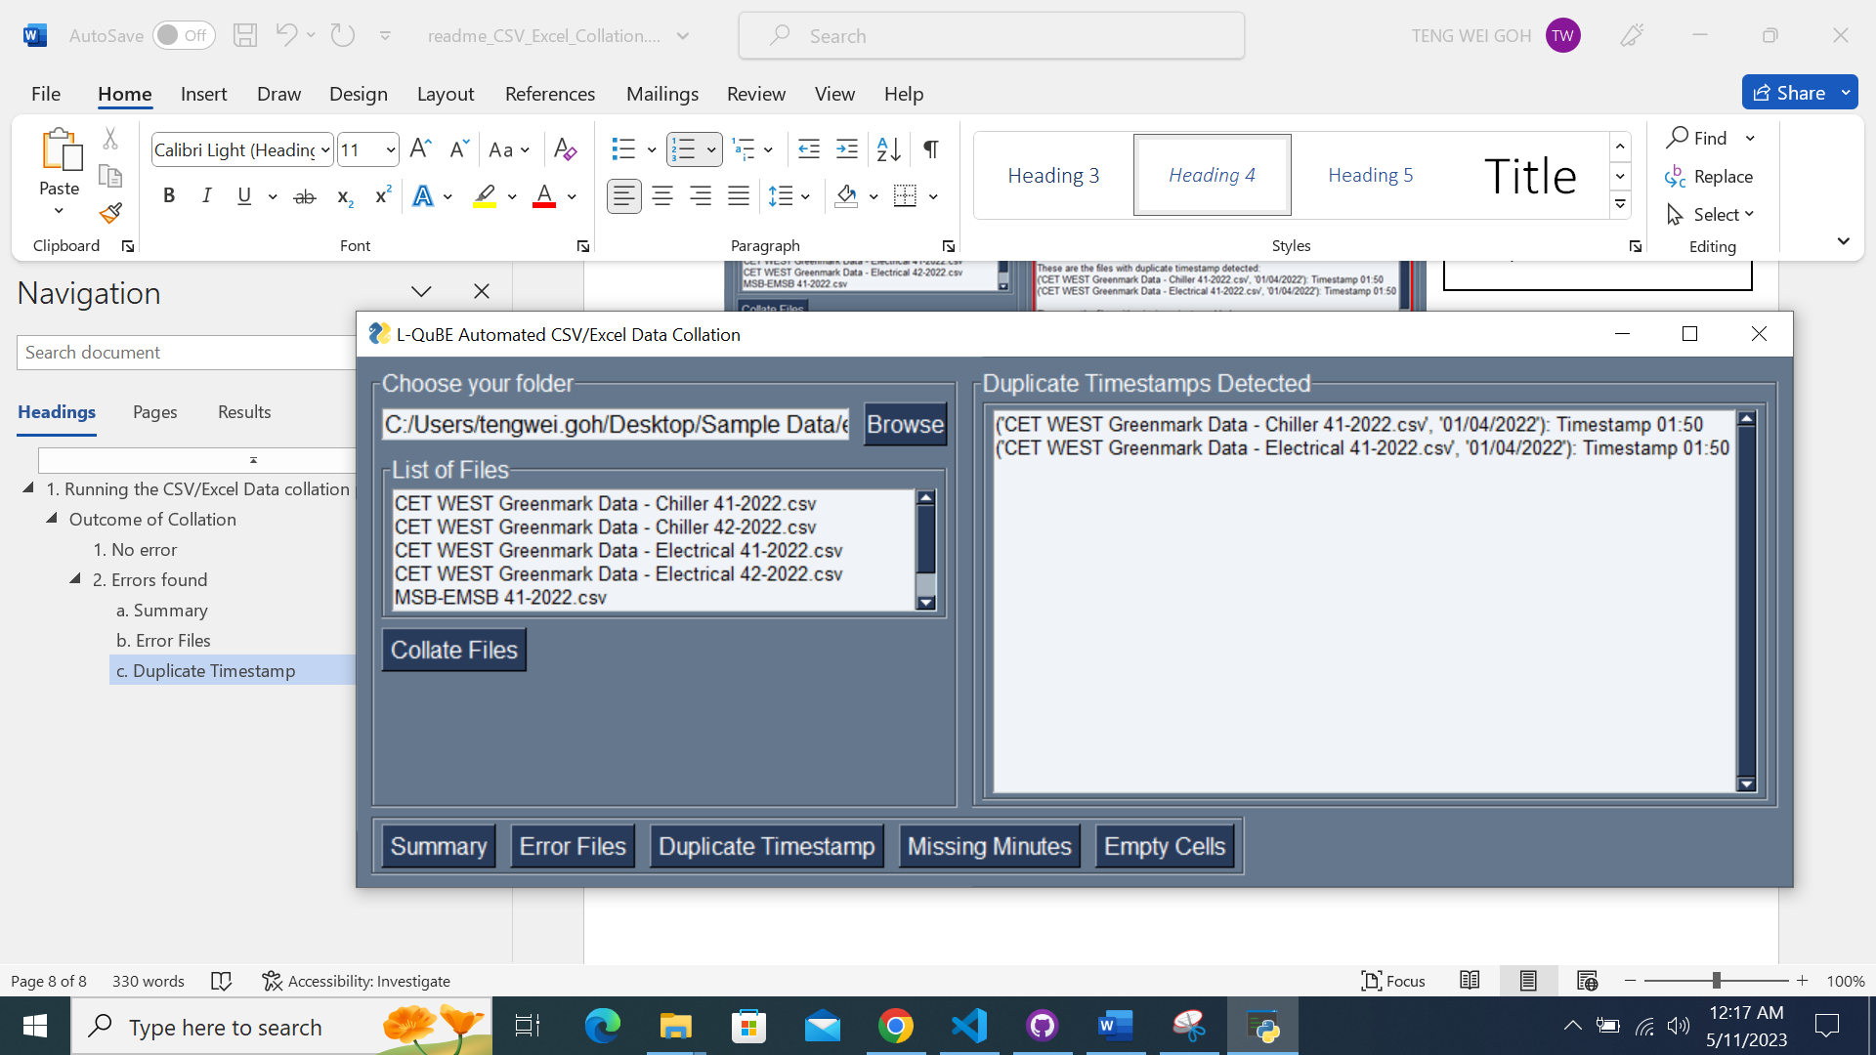

Click the ‘Duplicate Timestamp’ button to navigate to the Duplicate Timestamp page.



The file(s) with duplicate timestamps will be displayed along with the actual timestamp that has duplication.

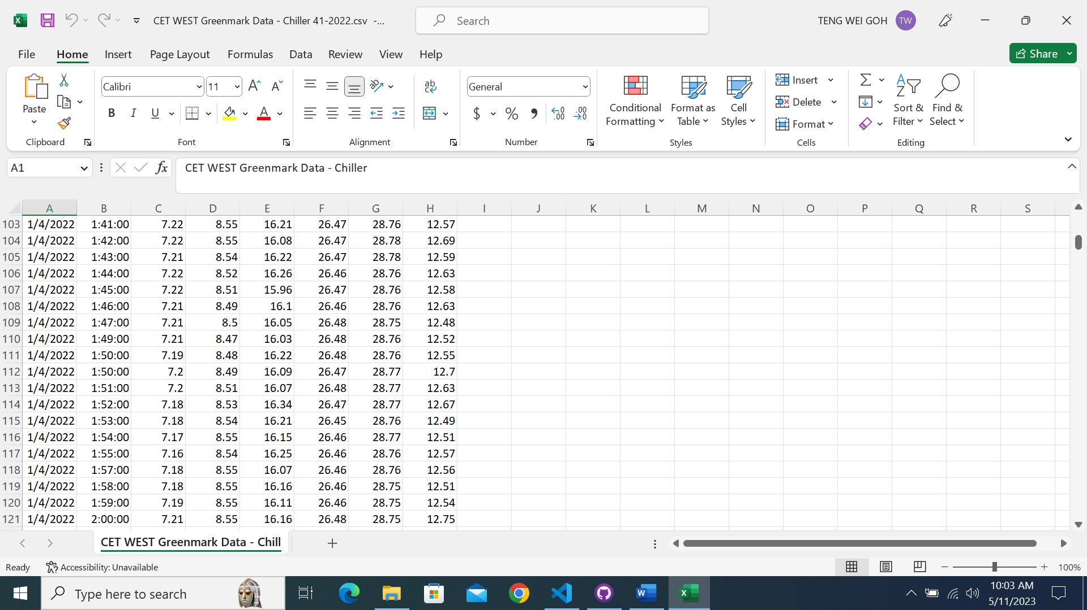

As indicated by the program, the file ‘CET WEST Greenmark Data – Chiller 41-2022.csv’ has a duplicate timestamp at 01:50, which can be verified by checking the file and locating the timestamp 01:50.

Likewise, it is the same for the file ‘CET WEST Greenmark Data – Electrical 41-2022.csv’.

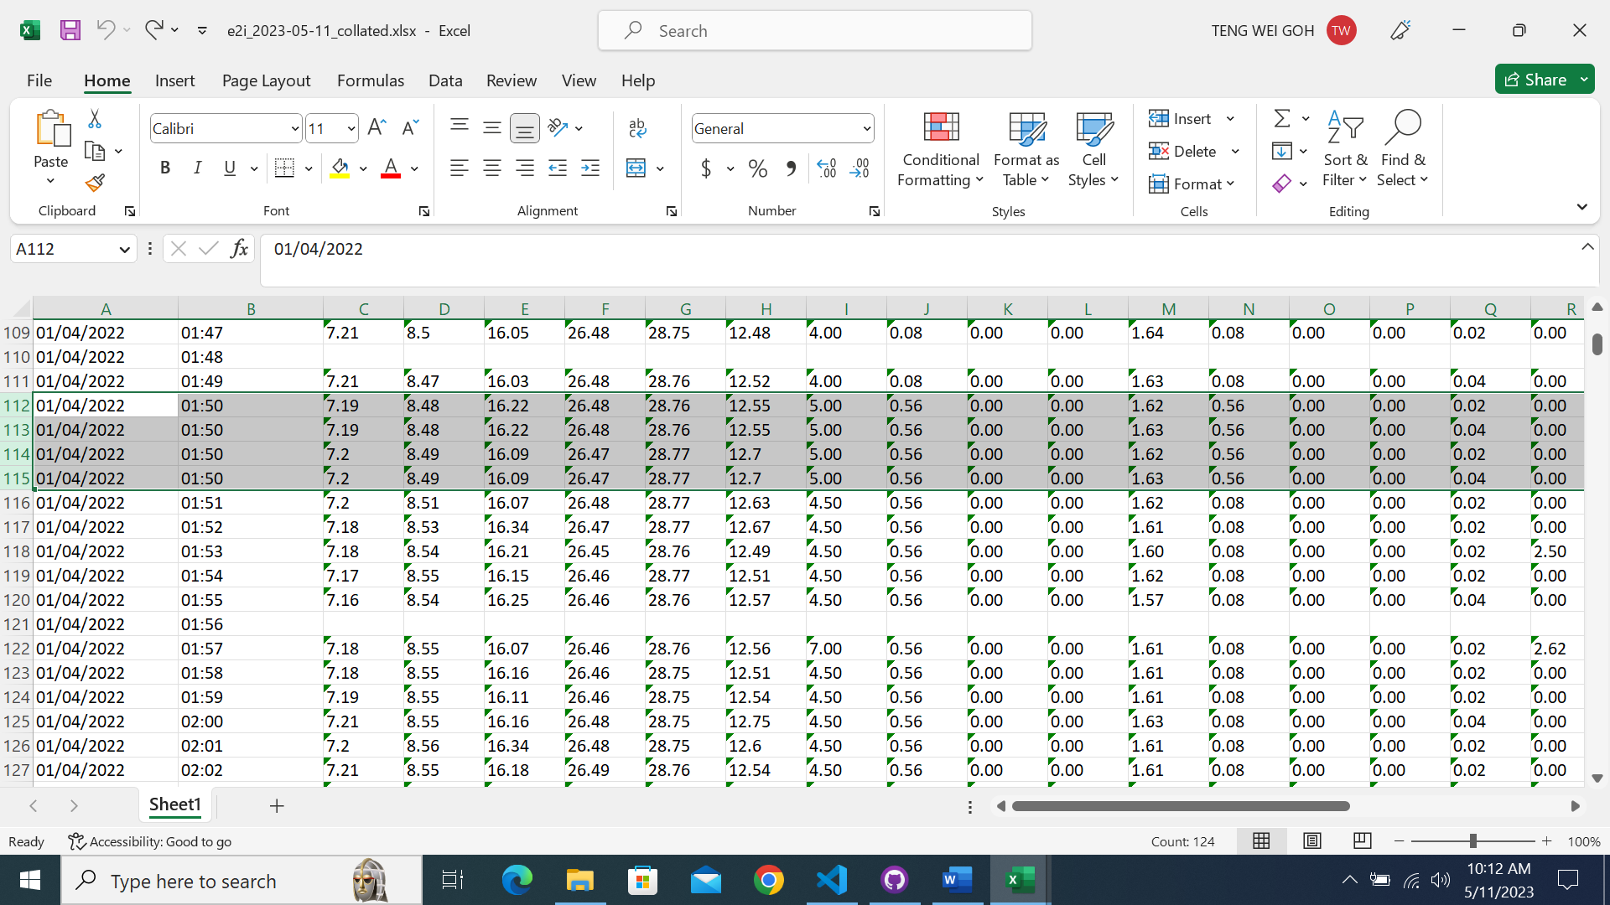

As both ‘CET WEST Greenmark Data – Chiller 41-2022.csv’ and ‘CET WEST Greenmark Data – Electrical 41-2022.csv’ has two duplicate timestamps at the **same timestamp on the same date**, **four rows of data** will be generated in the collated file.

This is because **the program will not decide which rows of data is the correct rows of data**, hence it will include every duplicated timestamp row in the collated file for you to decide which row to keep or discard.

If the duplicated timestamps are at different timestamp or on different date, then no additional rows will be generated.

##### Explanation of the number of rows generated in the collated file due to duplicate timestamps

Example 1

**If the duplicate timestamps are at the same timestamp and on the same date, then the number of duplicated timestamp rows generated is dependent on the number of duplicate timestamps in the files.**

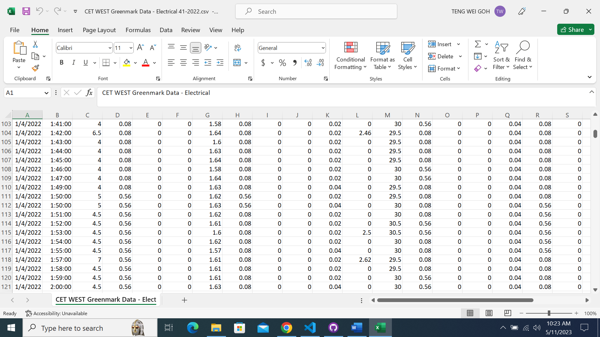

‘CET WEST Greenmark Data – Chiller 41-2022.csv’ has **2** duplicated timestamps as shown

‘CET WEST Greenmark Data – Electrical 41-2022.csv has **2** duplicated timestamps as shown

The resultant number of duplicated timestamp rows in the collated file will be **2x2**, which is **4 rows**.

Example 2

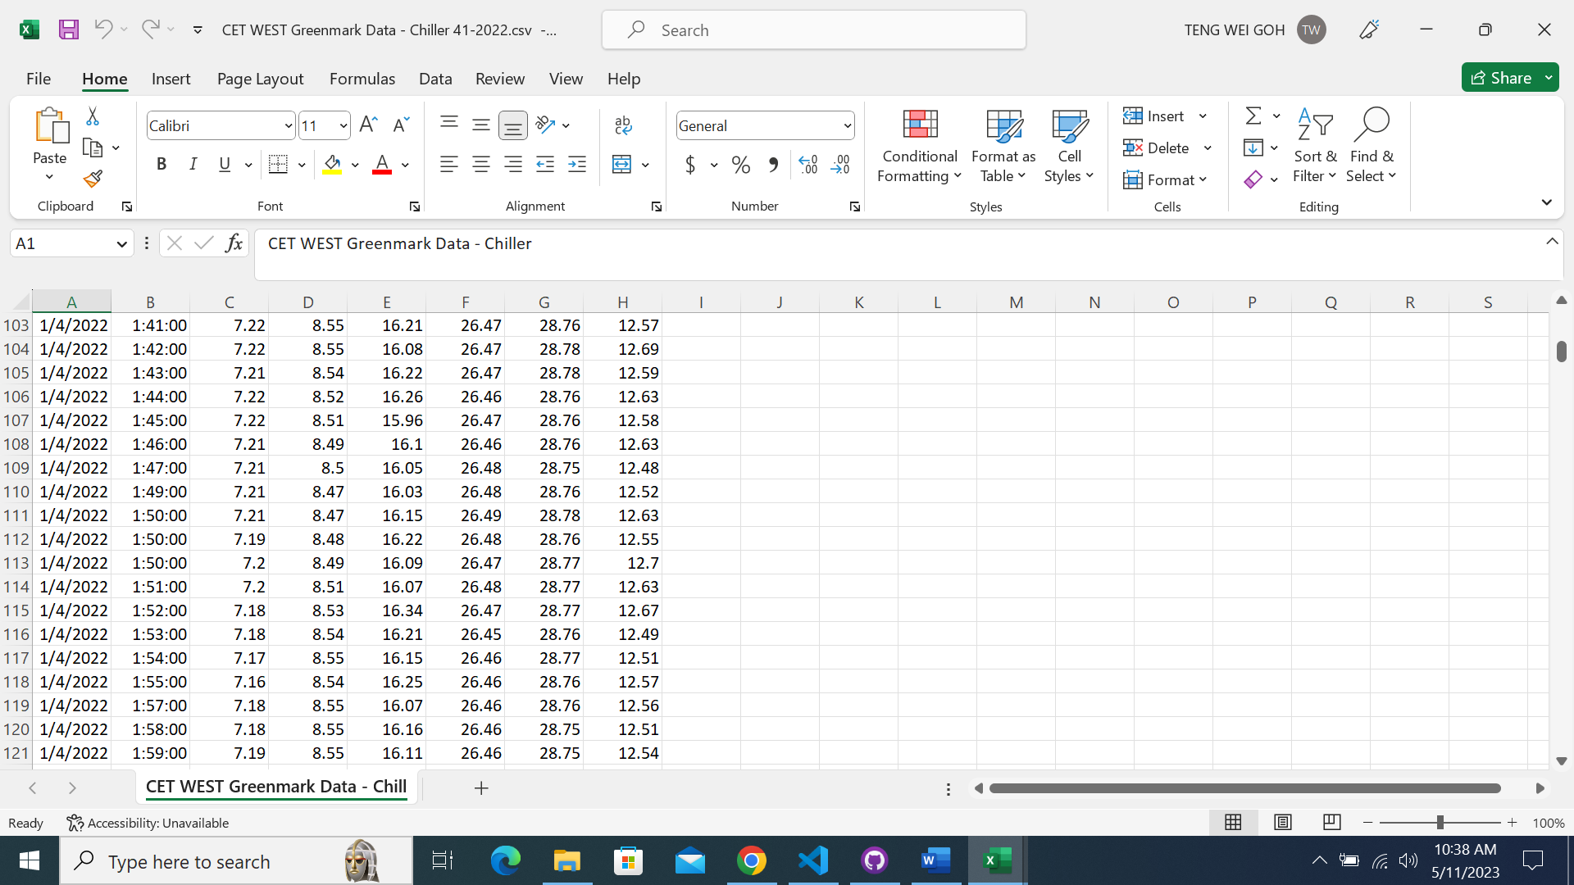

‘CET WEST Greenmark Data – Chiller 41-2022.csv’ has **3** duplicated timestamps as shown

‘CET WEST Greenmark Data – Electrical 41-2022.csv has **2** duplicated timestamps as shown

The resultant number of duplicated timestamp rows in the collated file will be **3x2**, which is **6 rows**.

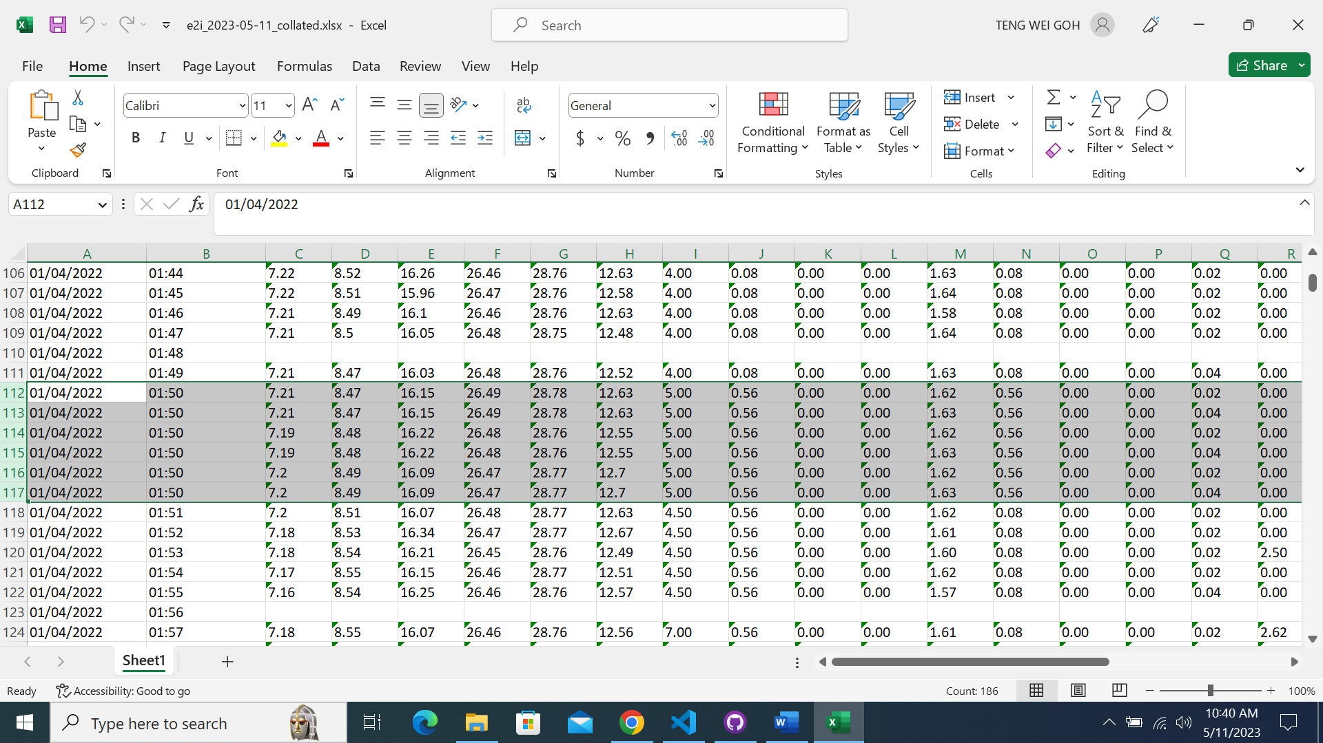

#### Missing Minutes Added

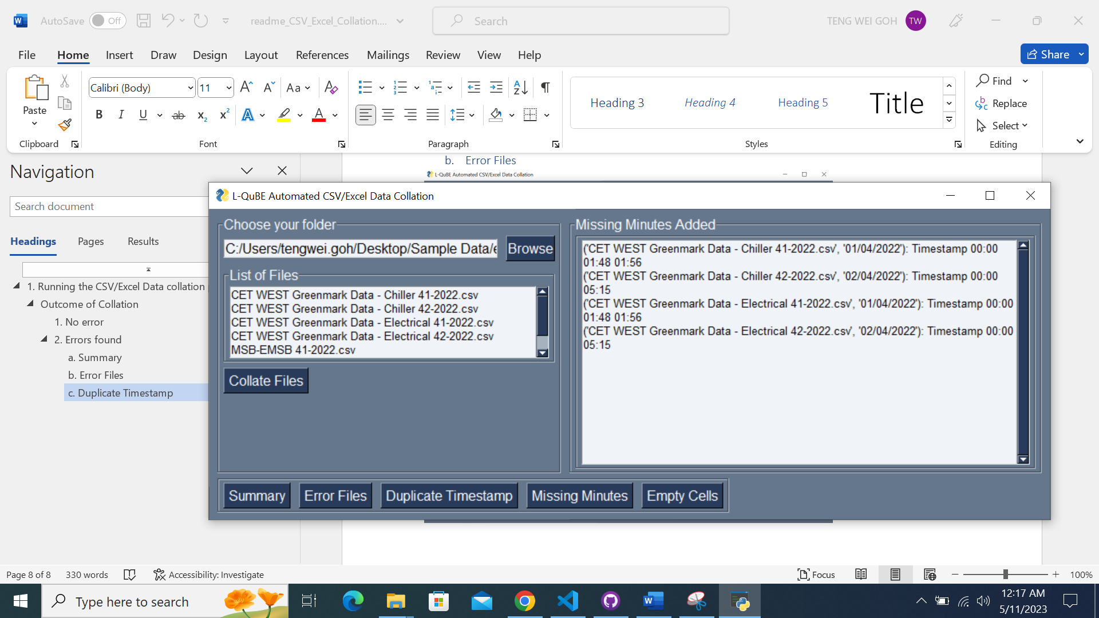

Any missing minute(s) added will be displayed in the Missing Minutes page.

Missing minutes added are minutes/timestamps that are not present in the original data file and inserted in the collated file.

Click the ‘Missing Minutes’ button to navigate to the Missing Minutes page.



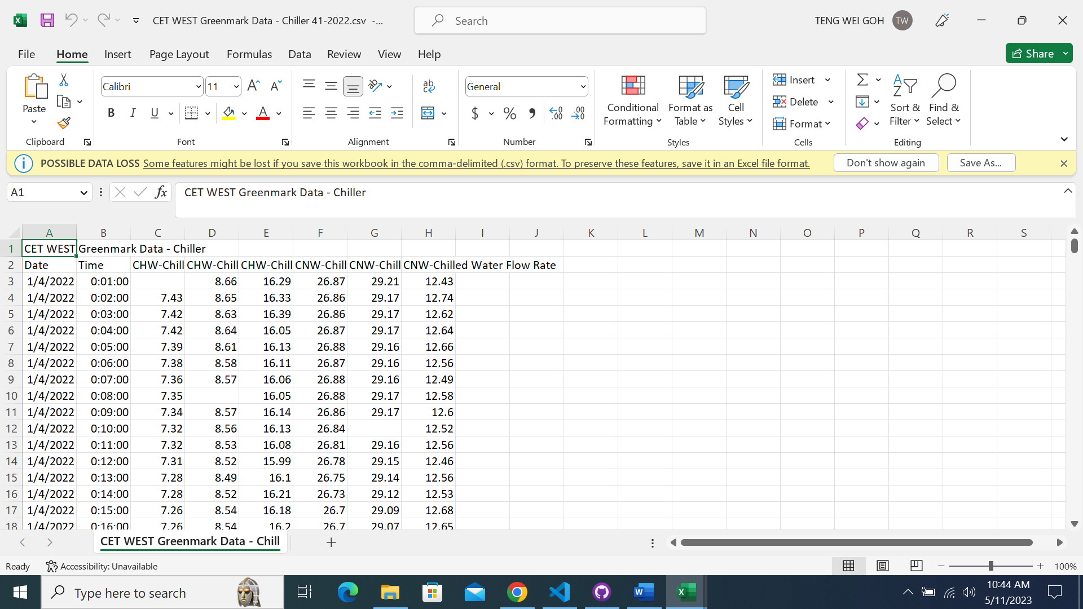

As indicated by the program, the file ‘CET WEST Greenmark Data – Chiller 41-2022.csv’ has missing minutes added at **00:00, 01:48 and 01:56**, which can be verified by checking the file and see that the data for timestamp 00:00, 01:48 and 01:56 are missing in the original data file.

Likewise, it is the same for the file ‘CET WEST Greenmark Data – Chiller 42-2022.csv’, ‘CET WEST Greenmark Data – Electrical 41-2022.csv’ and ‘CET WEST Greenmark Data – Electrical 42-2022.csv’.

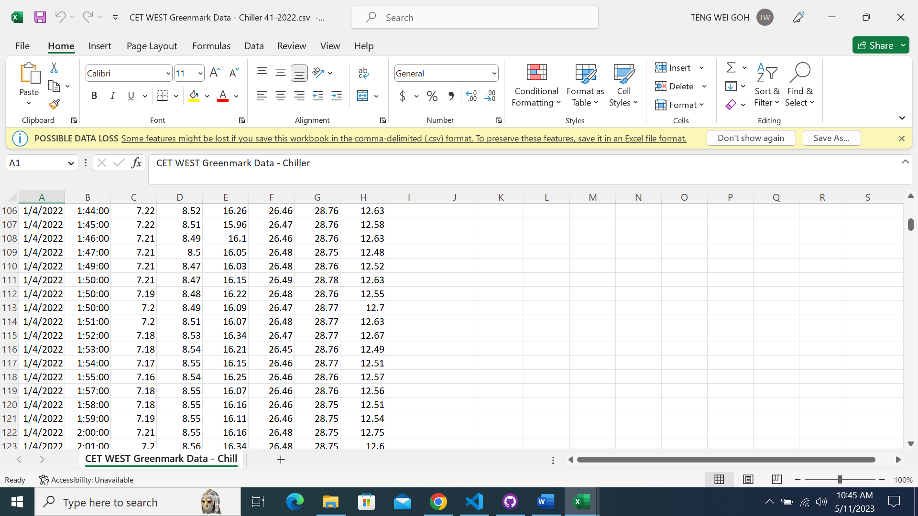

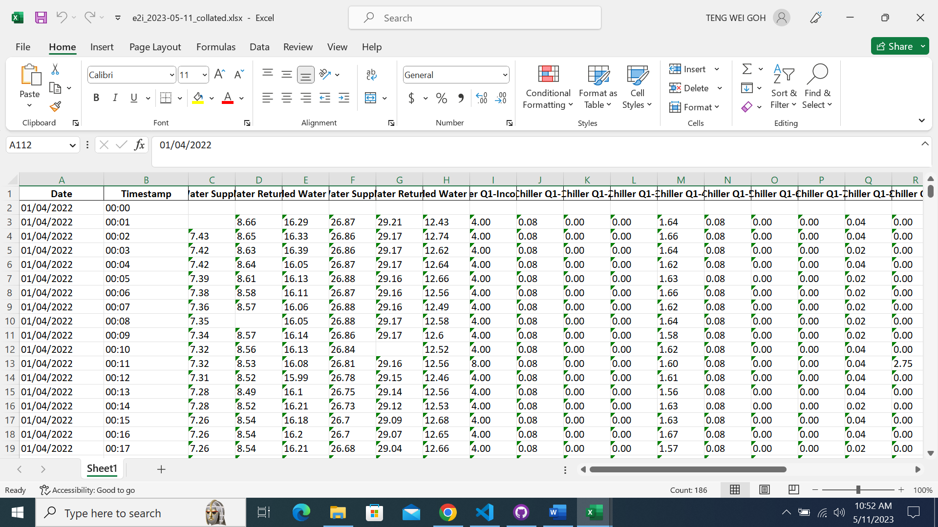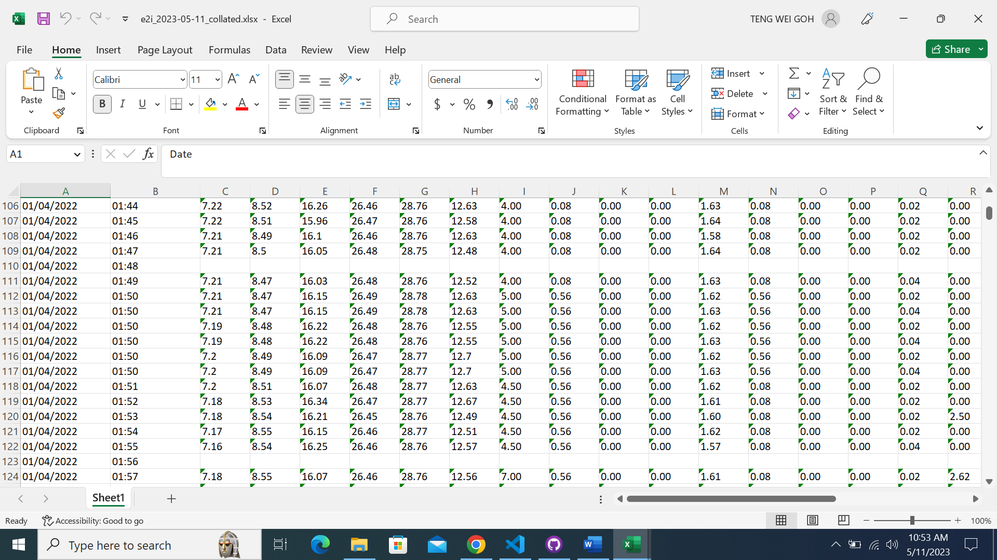

An empty row will be inserted for each missing minute in the original data file as seen in the image.

#### Empty Cells Detected

Any empty cell(s) detected will be displayed in the Empty Cells page.

Empty cells are cells in the original data file that has no value.

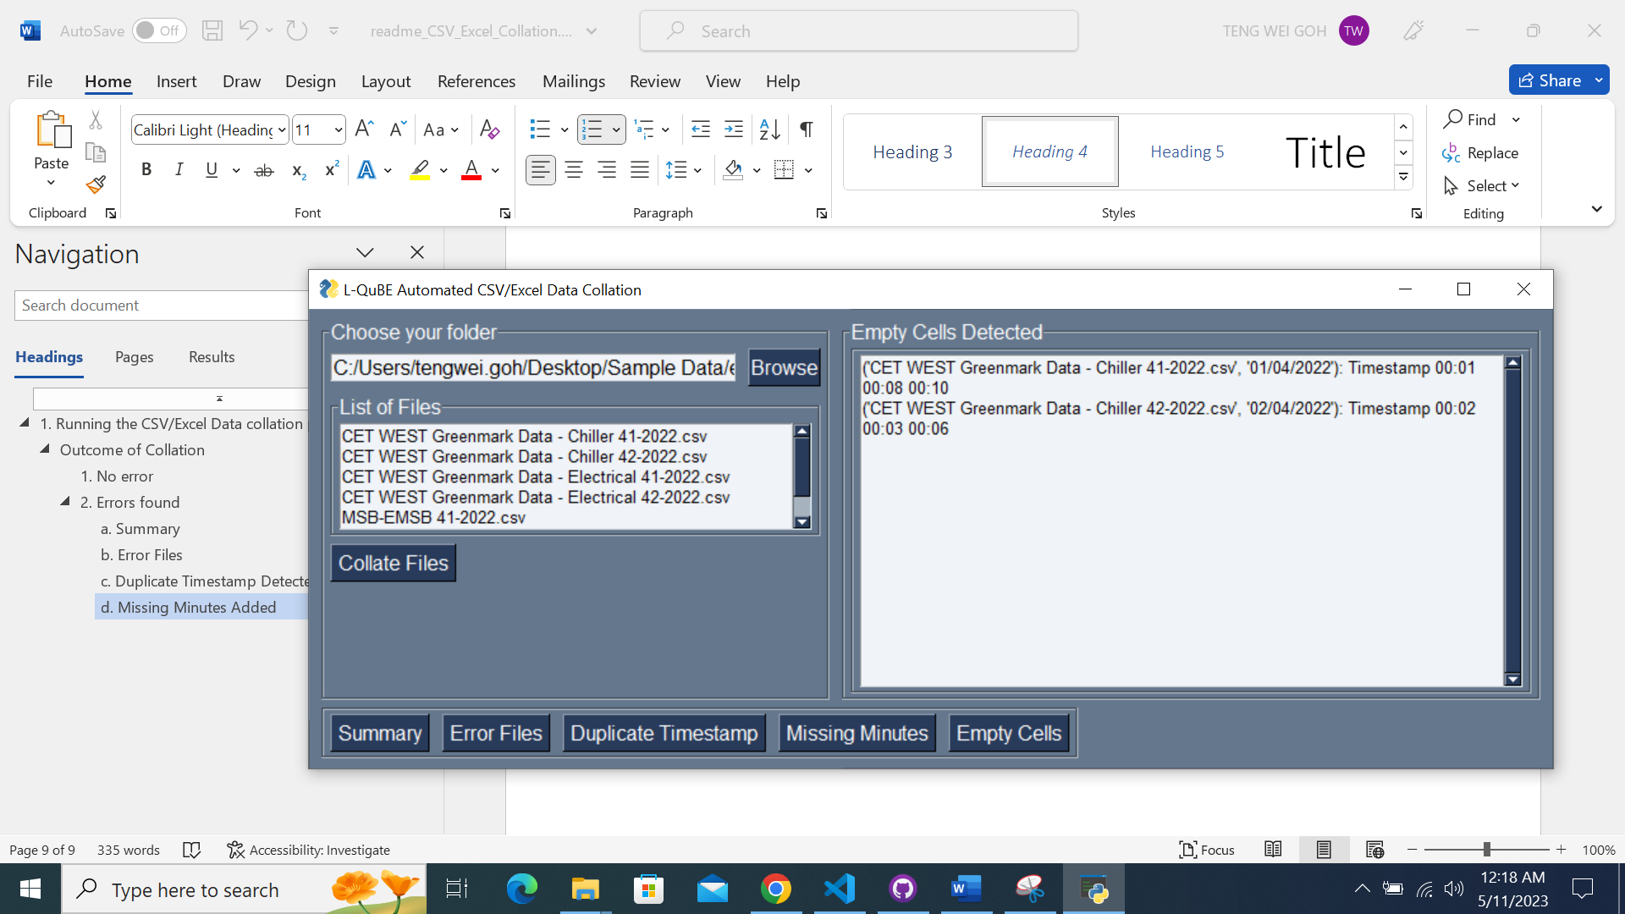

Click the ‘Empty Cells’ button to navigate to the Empty Cells page.



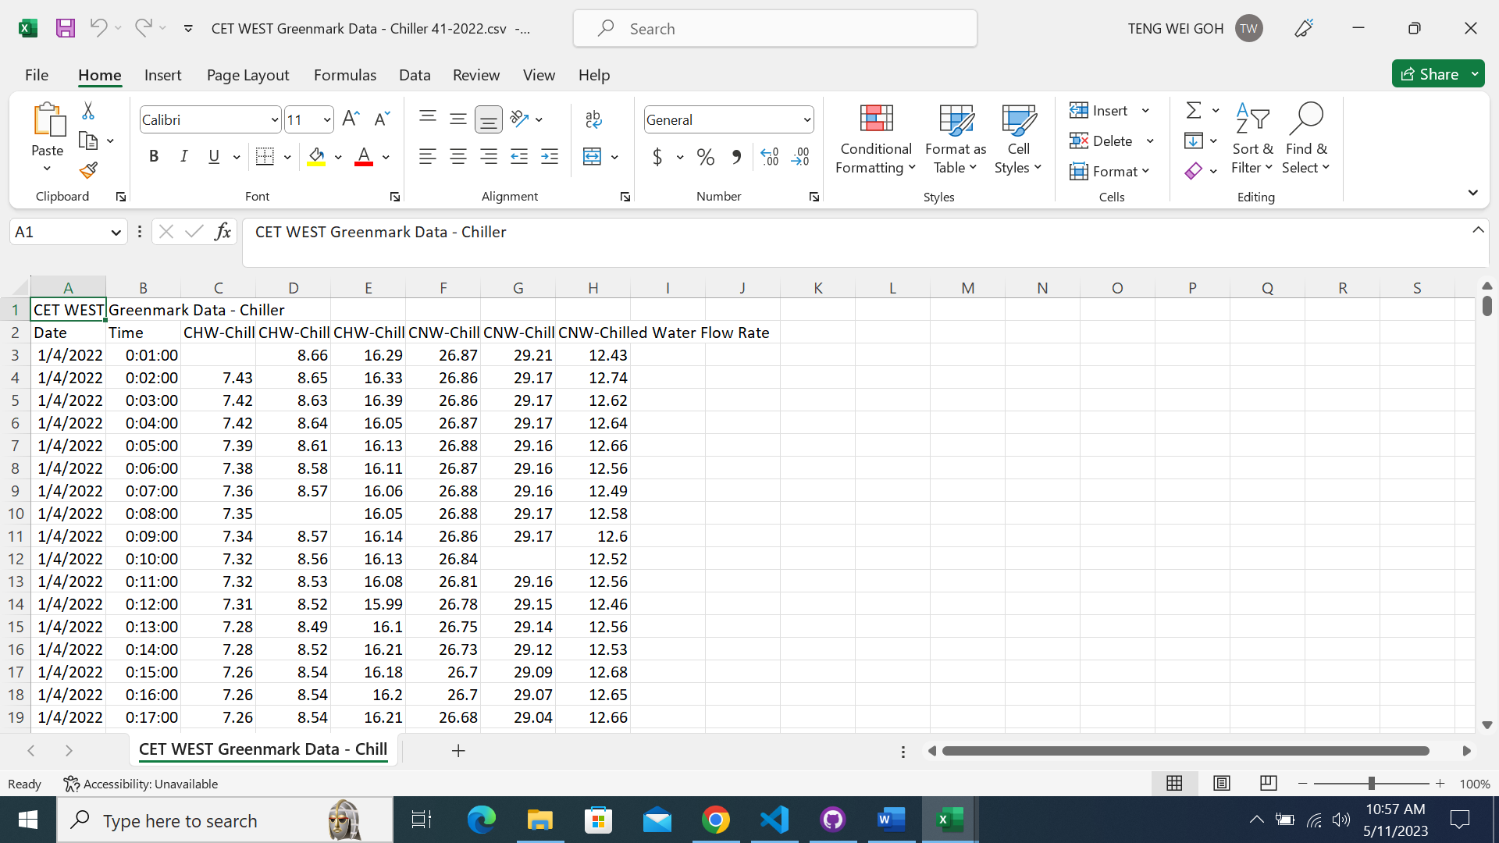

As indicated by the program, the file ‘CET WEST Greenmark Data – Chiller 41-2022.csv’ has empty cells detected at **00:01, 00:08 and 00:10**, which can be verified by checking the file and see that there are cells that has no value at **00:01, 00:08 and 00:10** in the original data file.

Likewise, it is the same for the file ‘CET WEST Greenmark Data – Chiller 42-2022.csv’.

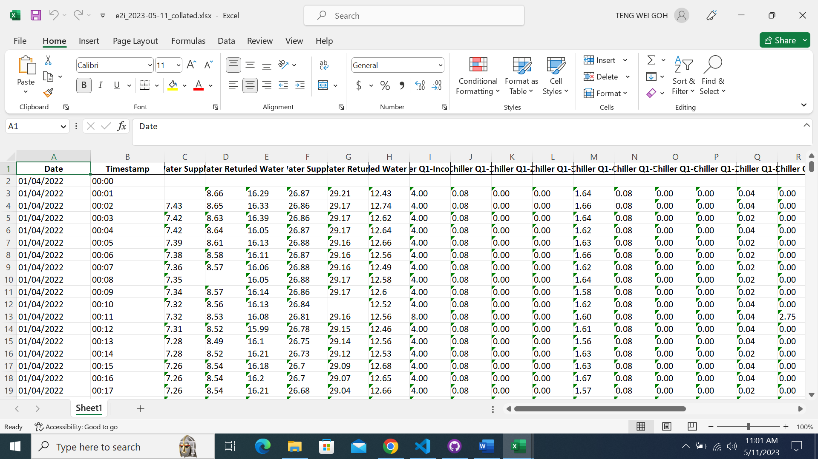

The empty cells detected will not be removed/ filled up and will be present in the collated file as an empty cell.